
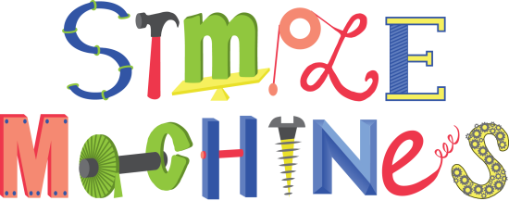

Chapter 12 Terms

- Compound machine 7. Machine 13. Wheel & Axle
- Efficiency 8. Mechanical advantage 14. Work
- Fulcrum 9. Power
- Inclined plane 10. Pulley
- Joule 11. Screw
- Lever 12. Wedge

Chapter 12 Terms

1. Compound machine 7. Machine 13. Wheel & Axle
- Efficiency 8. Mechanical advantage 14. Work
- Fulcrum 9. Power
- Inclined plane 10. Pulley
- Joule 11. Screw
- Lever 12. Wedge







